1) Create a user jack and assign a password alberto, This is user should be member of wheel group as well as nobody group.
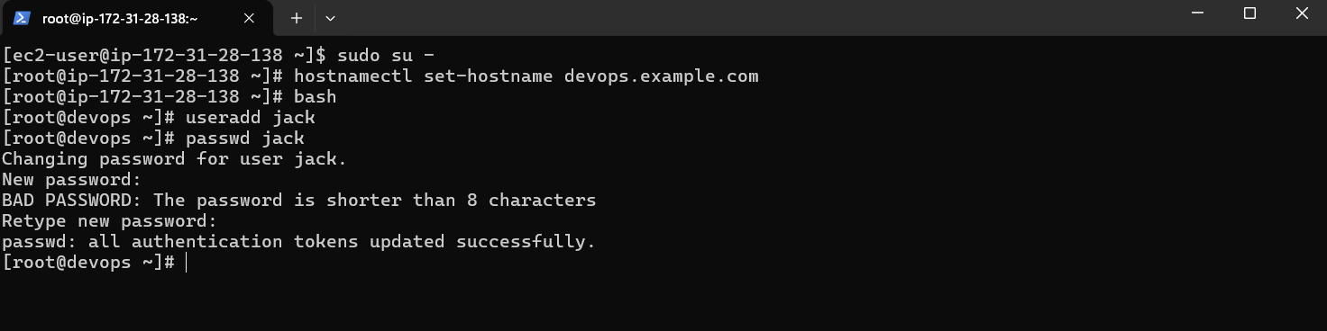
User jack is added and password is set as alberto.
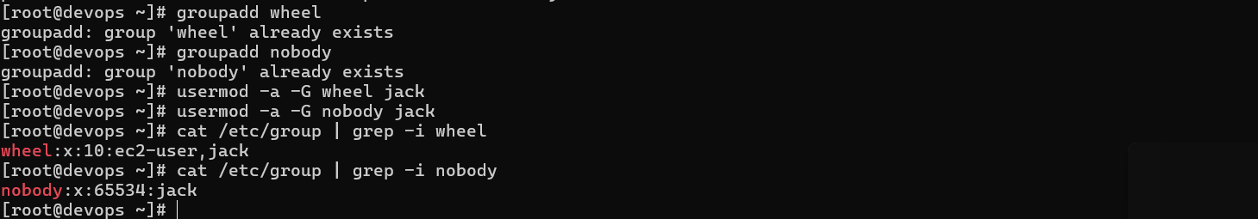
Groups are created and jack is a member of both group.

2) Put a new Java project on GitHub. Create a Jenkins project and integrate it with GitHub. Now add the maven package goal in the Jenkins project. Also make sure the artifacts which are built are saved in the pipeline.
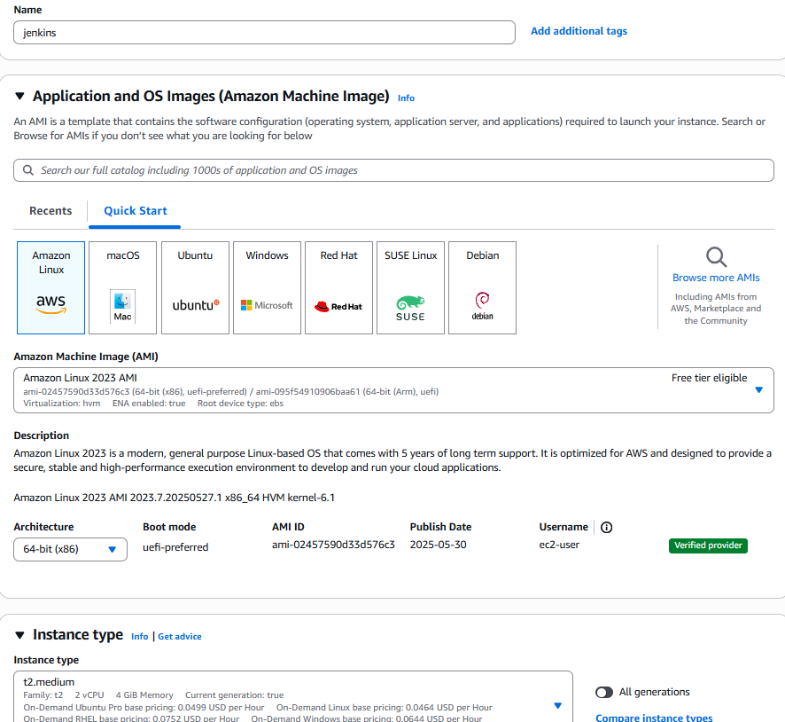
For Jenkins t2.medium is choosen.
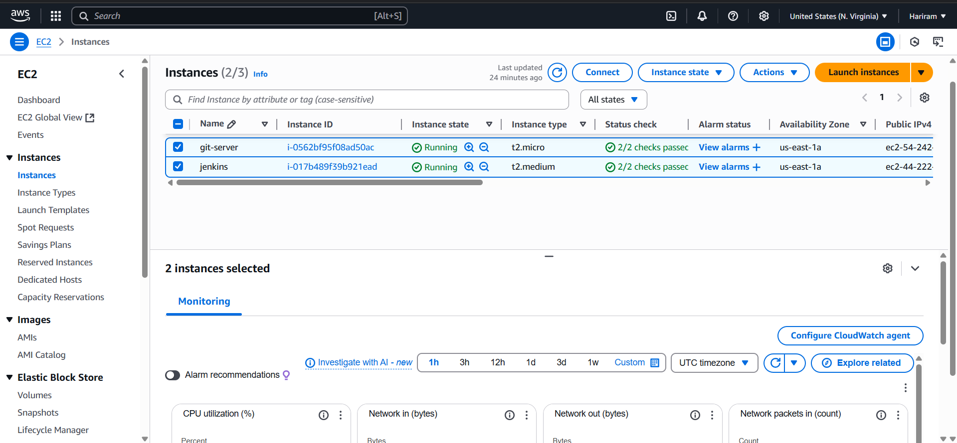
Two instances are created one for github and another for Jenkins
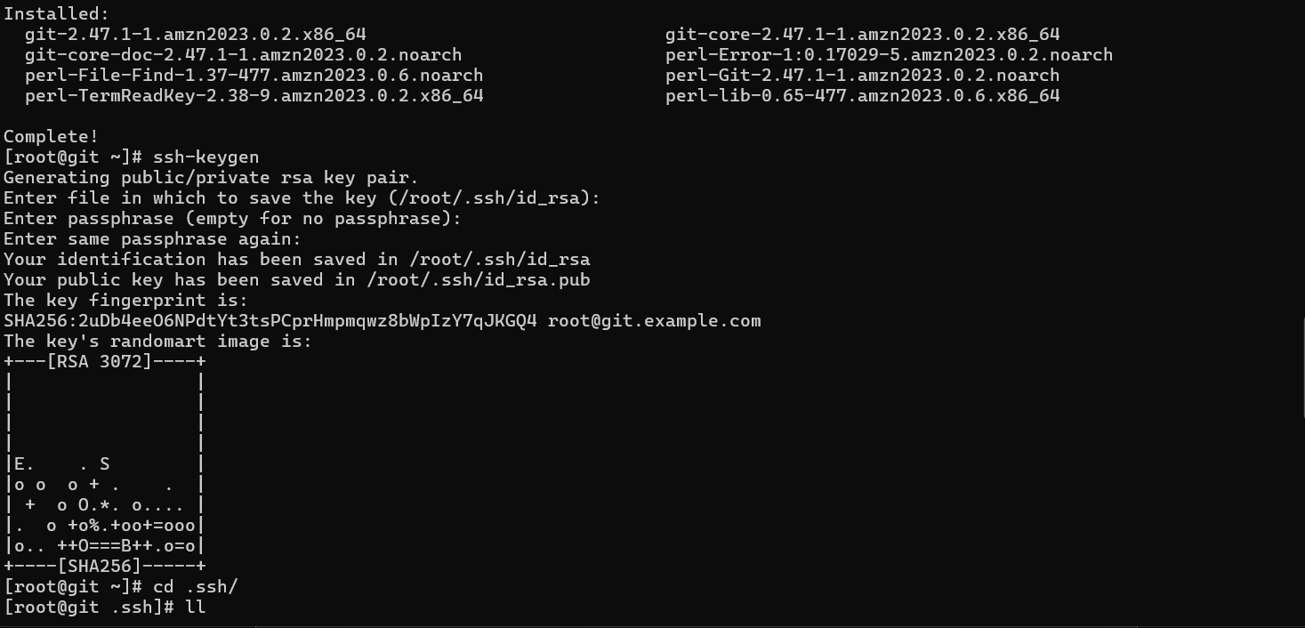
Git is installed on git-server and ssh key is generated
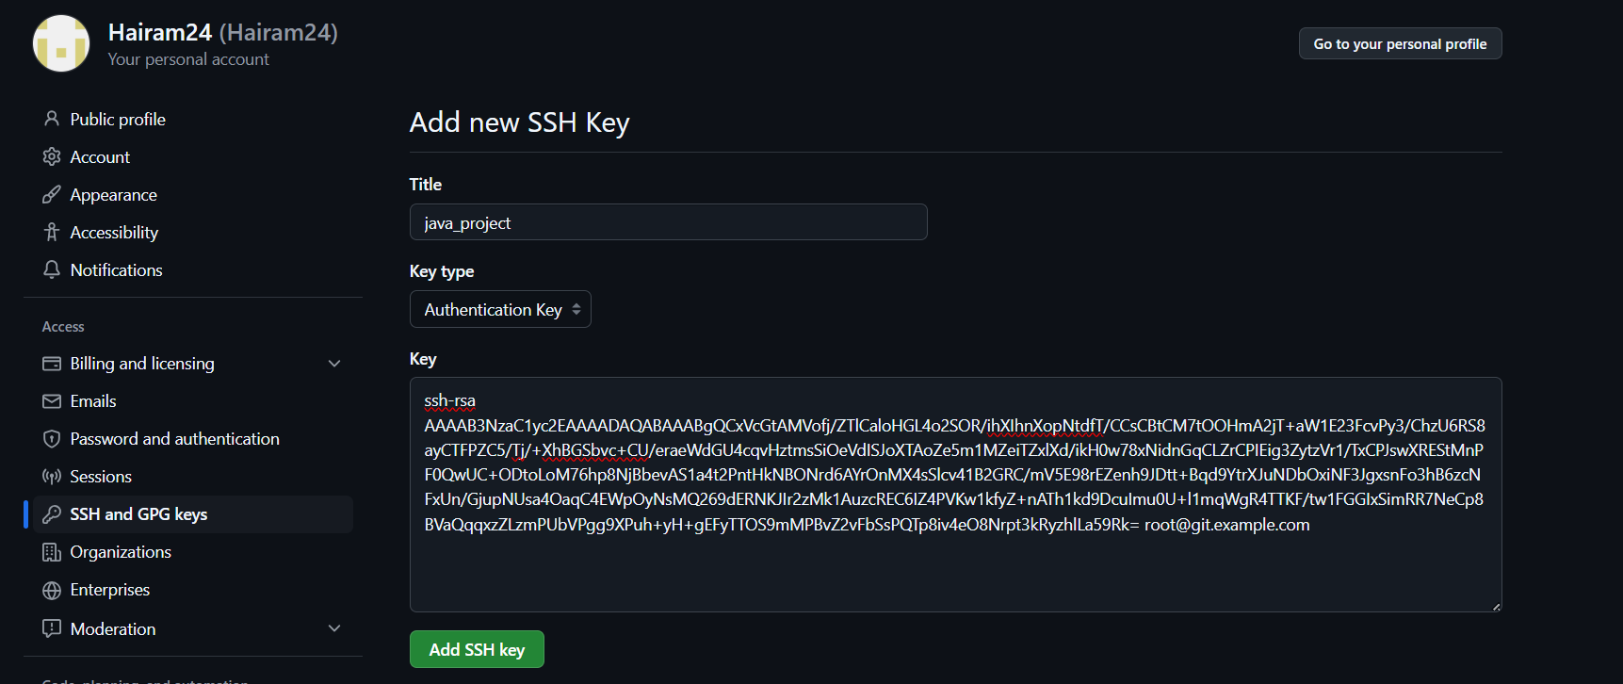
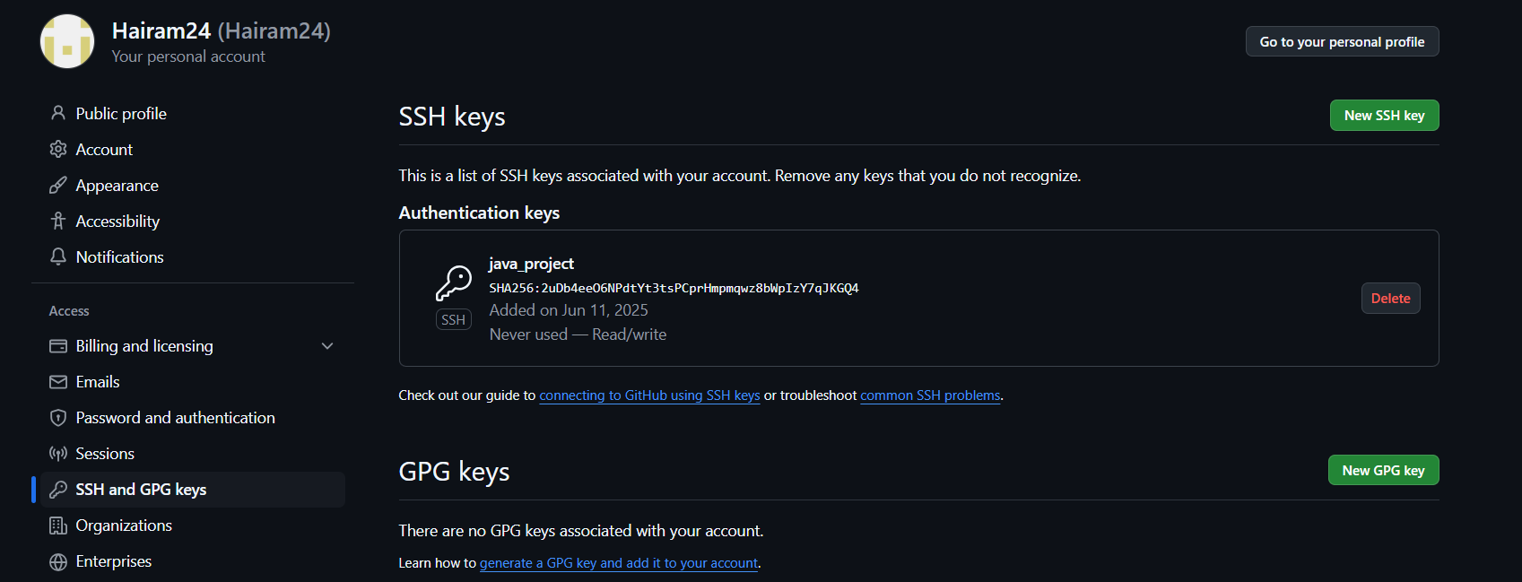
Ssh key add to github
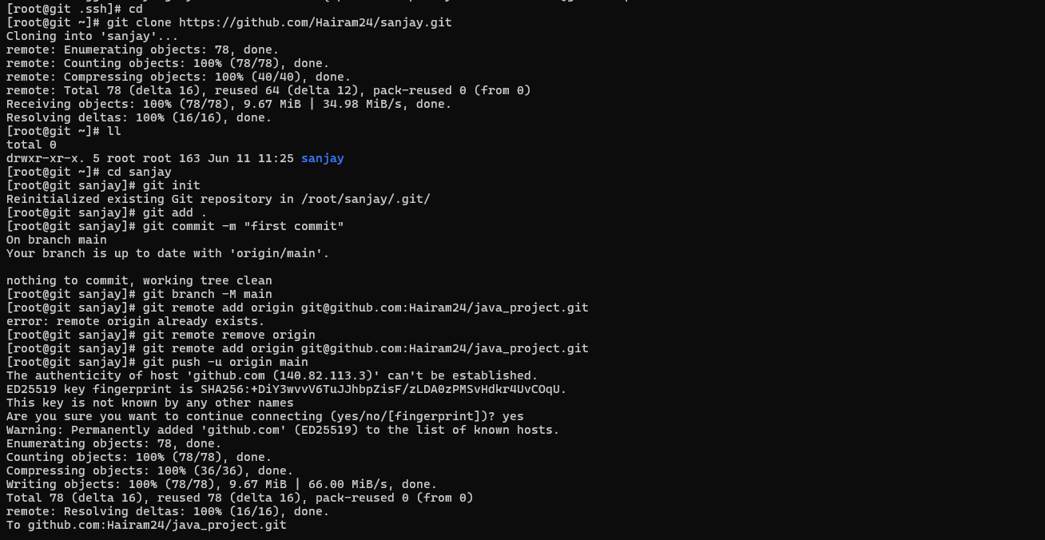
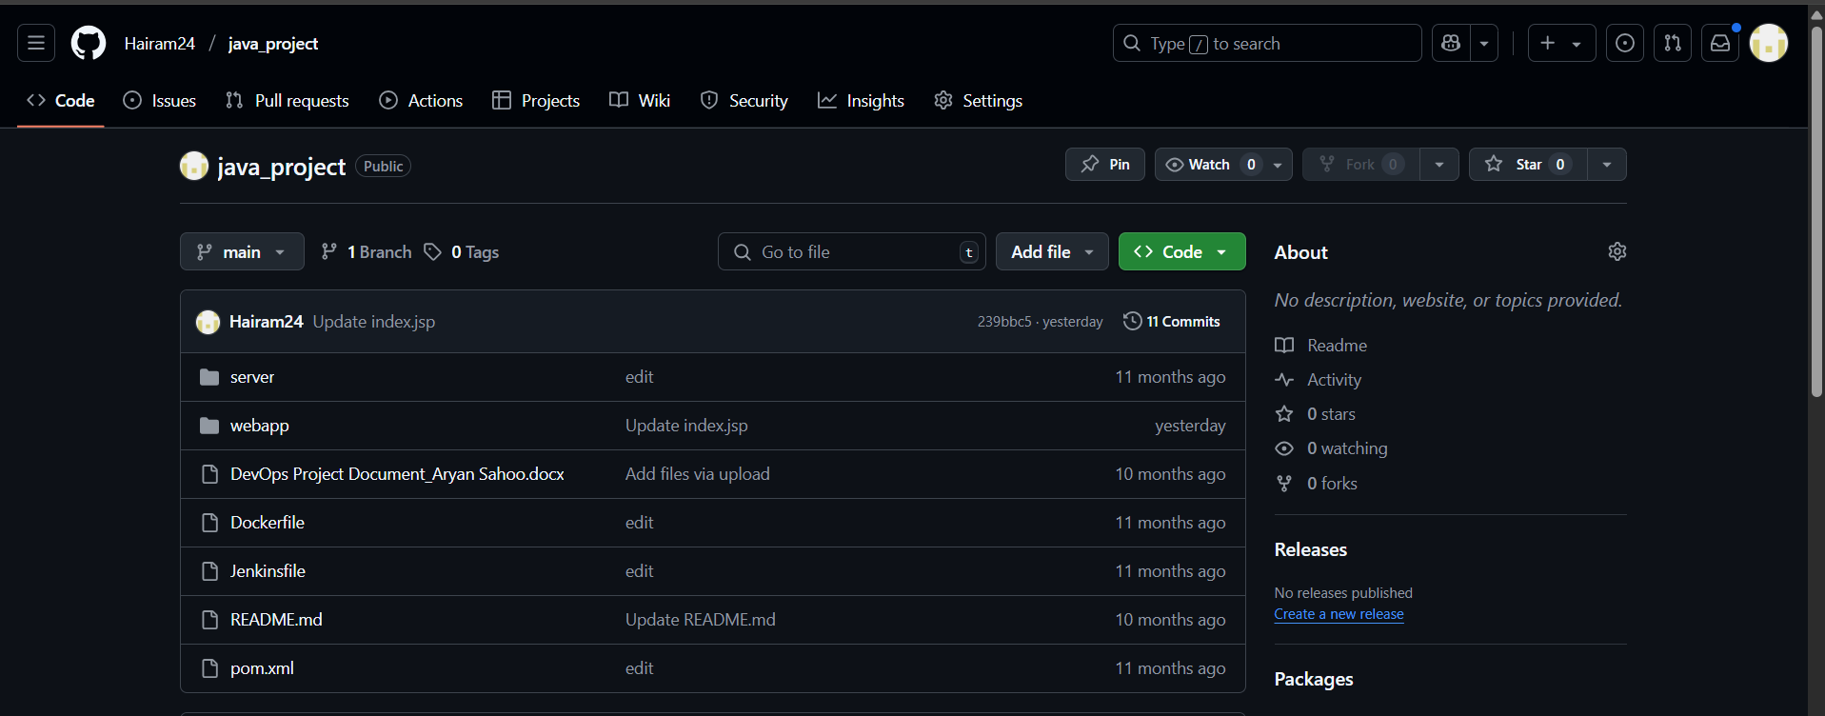
Java project is cloned to java_project git repo.
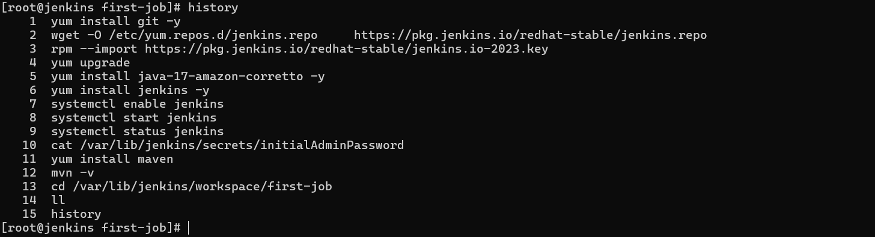
In the jenkins server , Jenkins ,git and maven are installed (java is installed with Jenkins package because Jenkins runs on java)
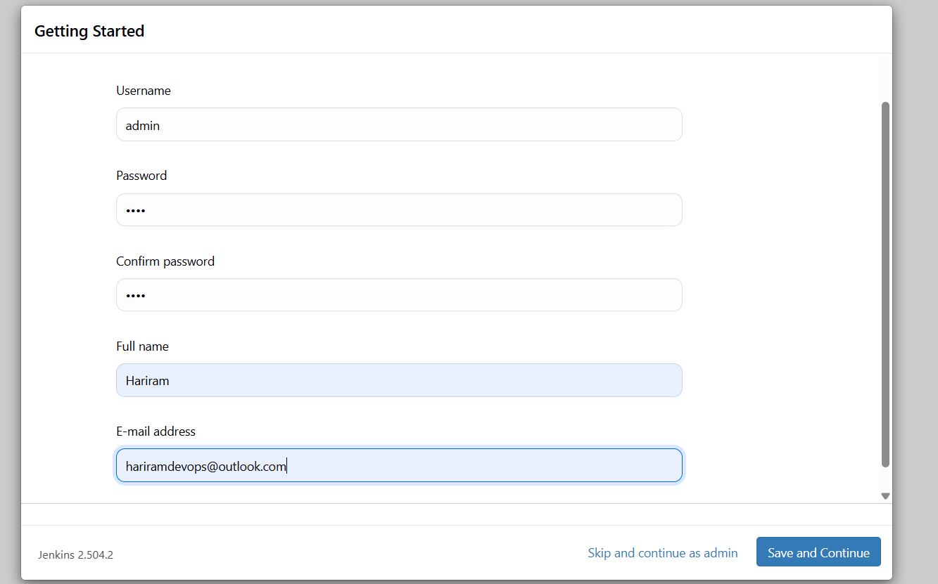
Jenkins gets started using Jenkins public ip with port no 8080 as http://44.222.227.239:8080/
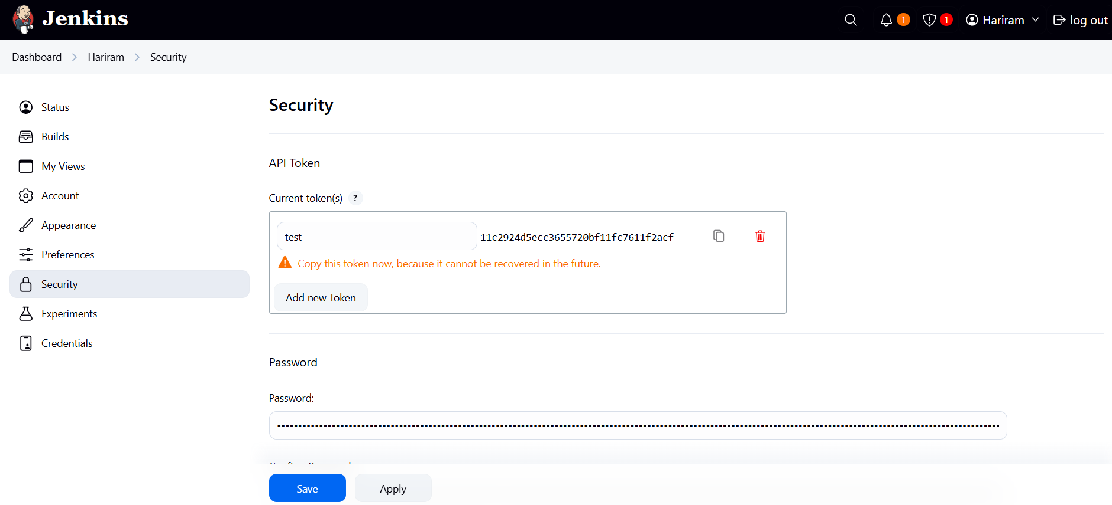Jenkins api token is generated.
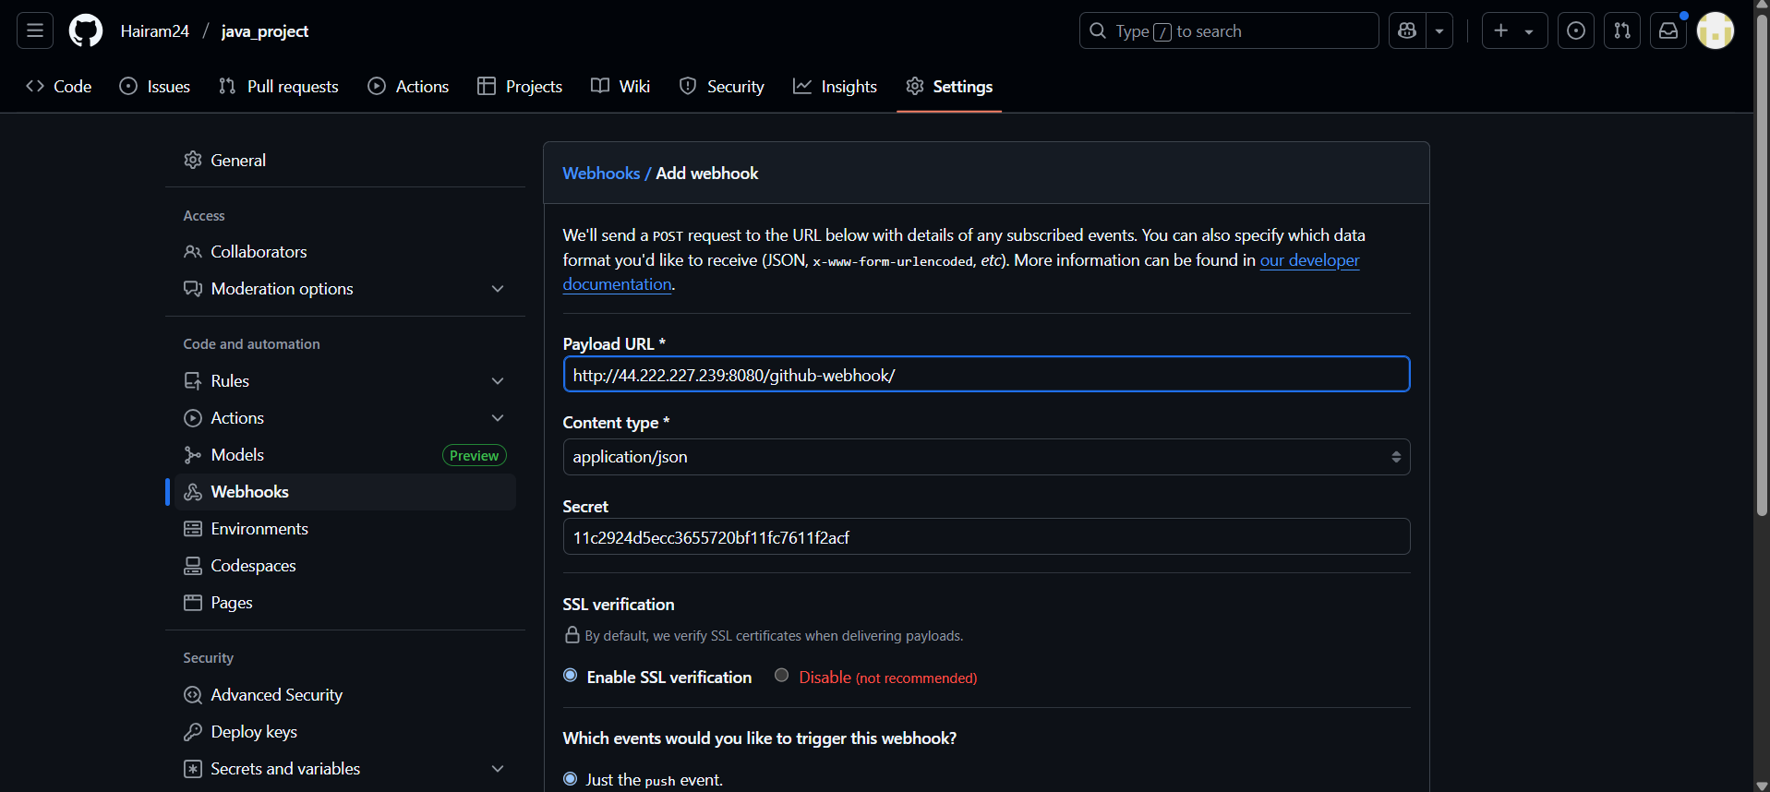
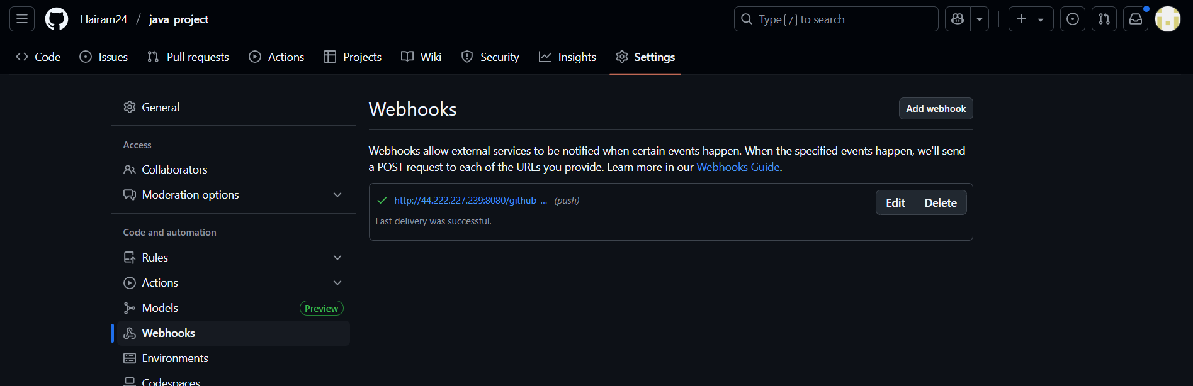
Jenkins connected to github through webhooks.
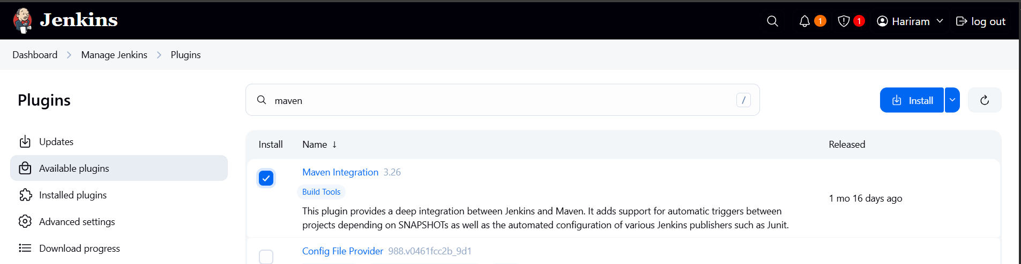
Rwquired plugins are installed and Jenkins restarted to apply changes.
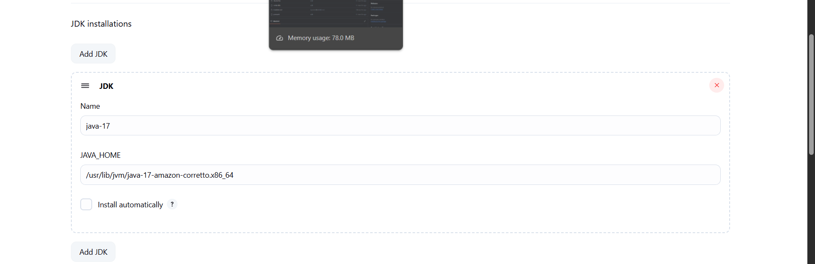
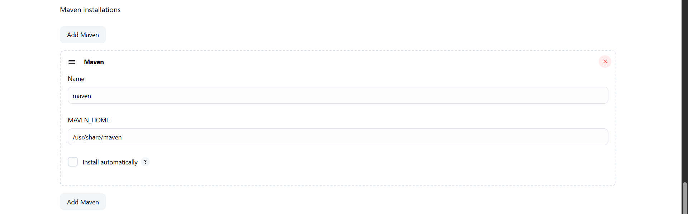
Java and maven path is configured using mvn -v cmd.
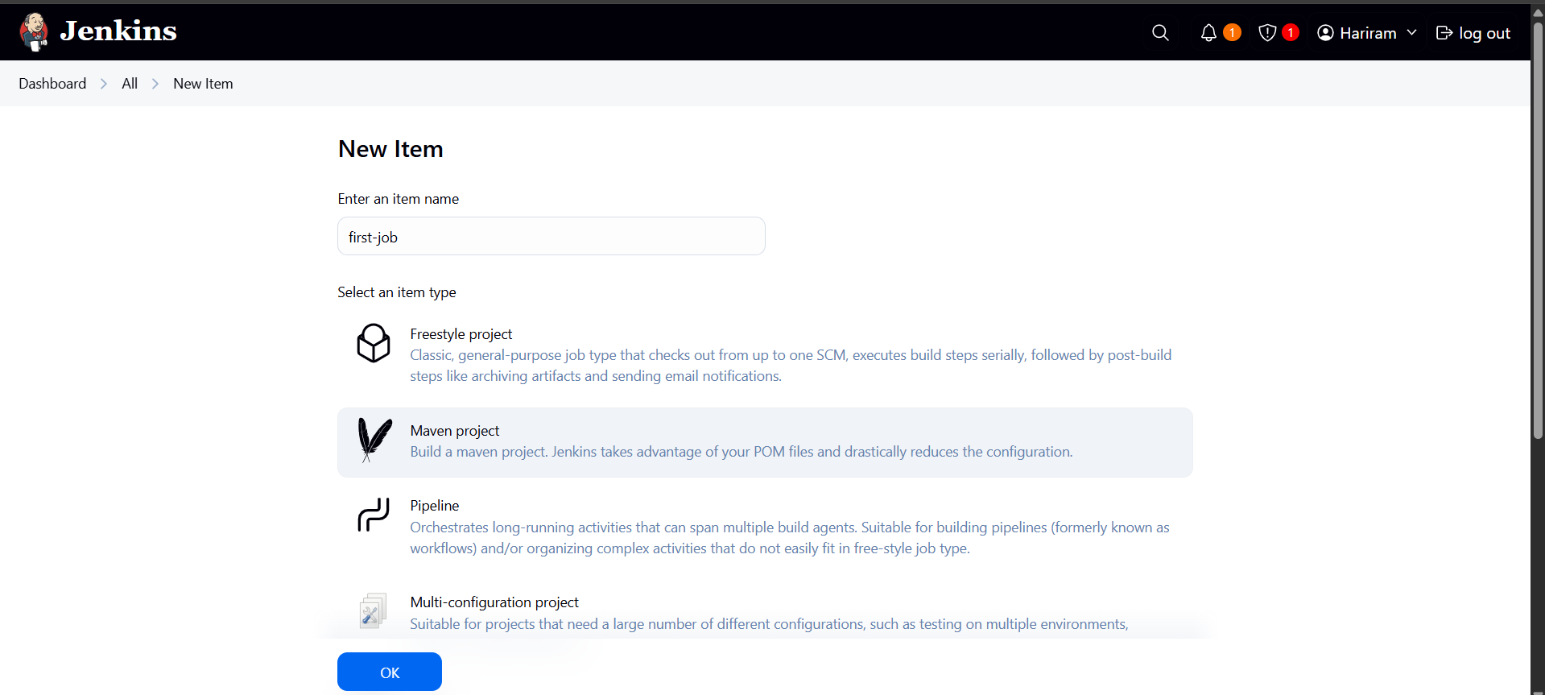
New job is created in maven project.
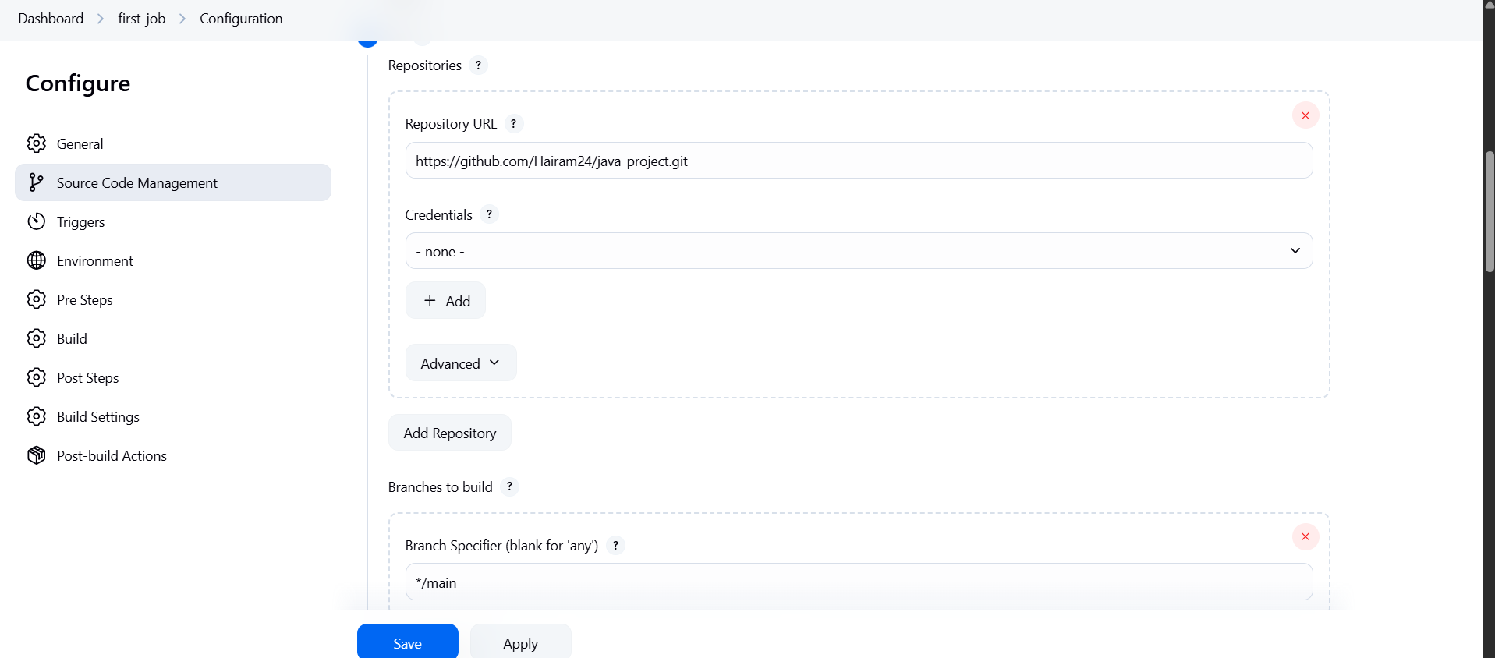
Job configuration is done (github is connected via https link). Branch specification is changed from */master to */main.
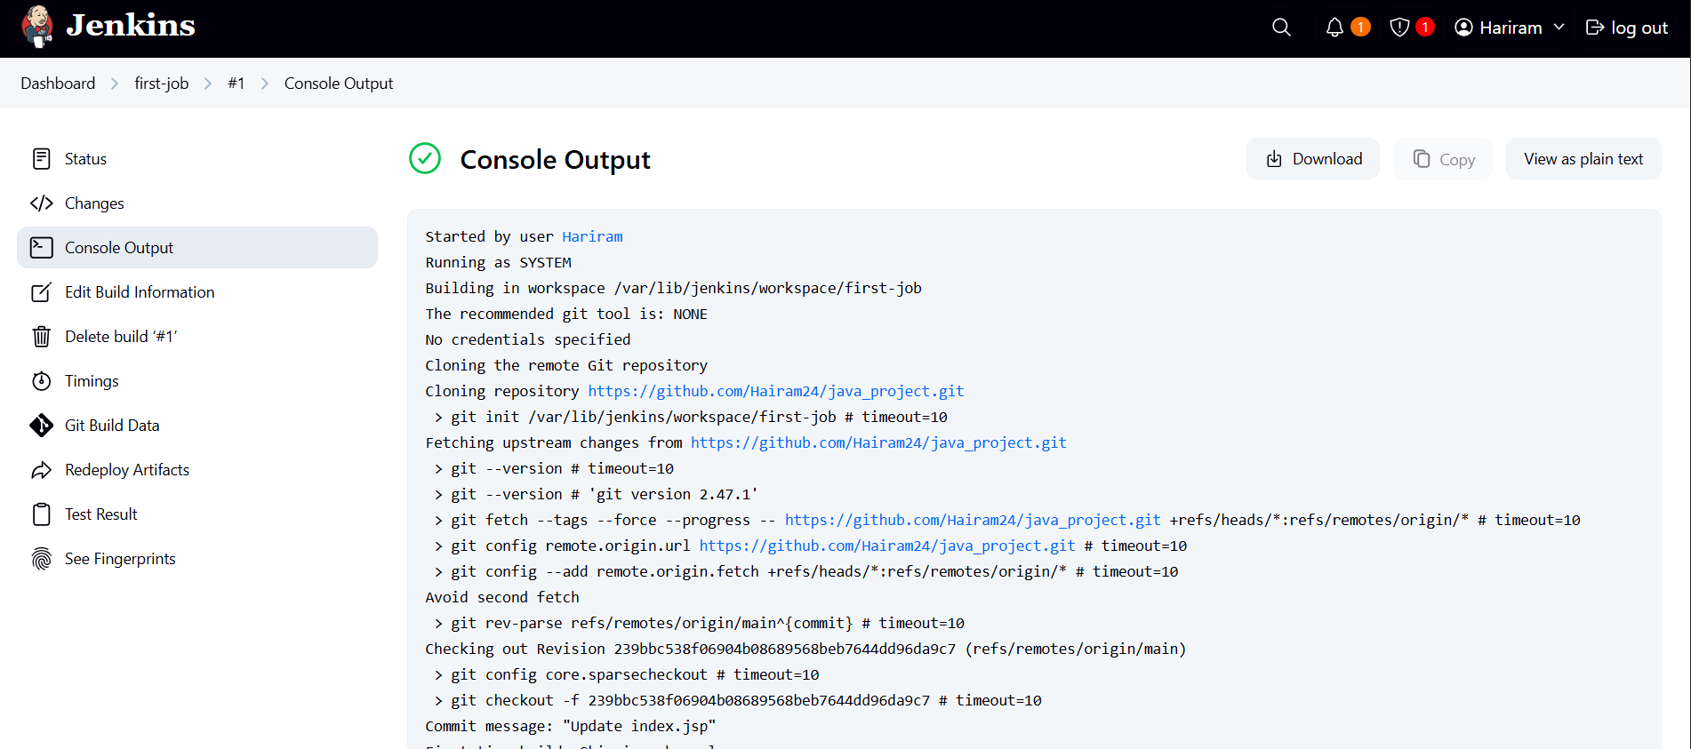
Build run successfully. Above is the Console output.
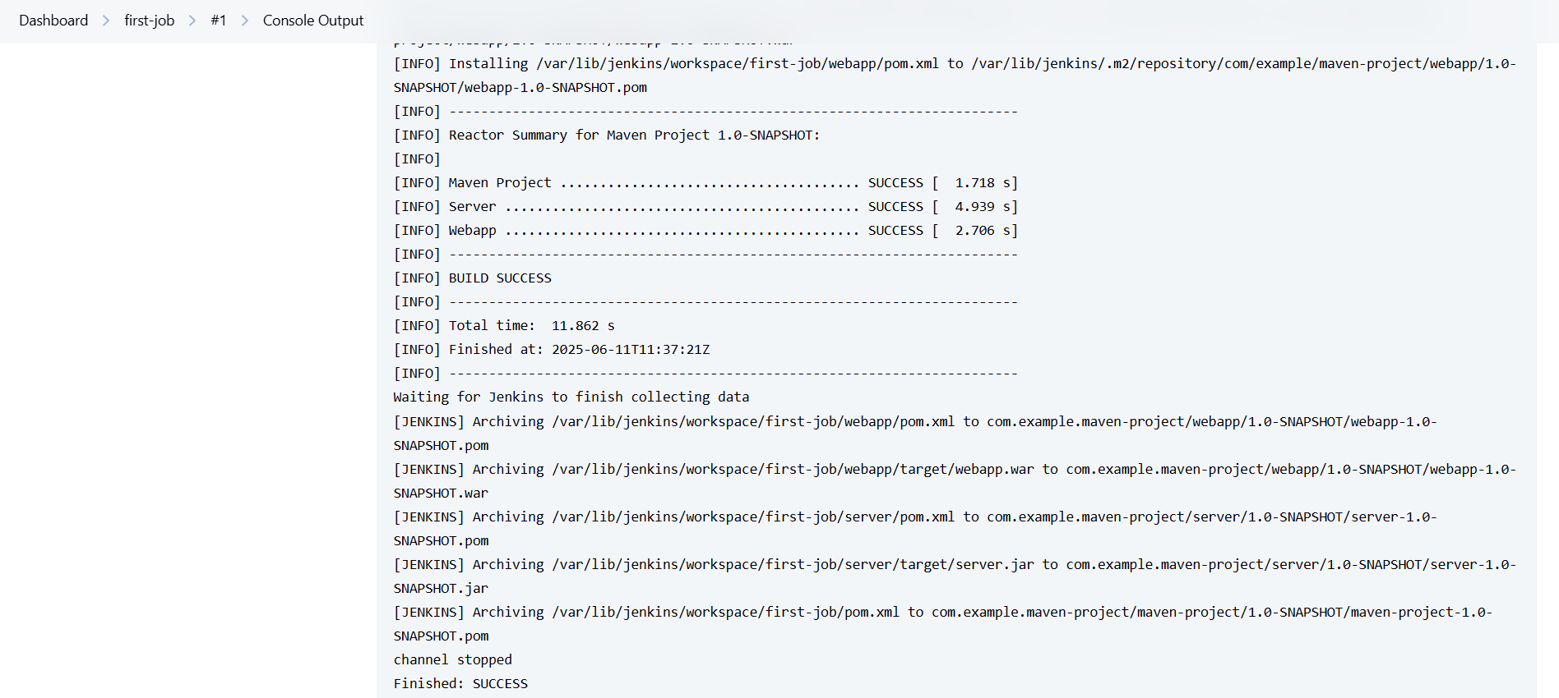
Build successfully.
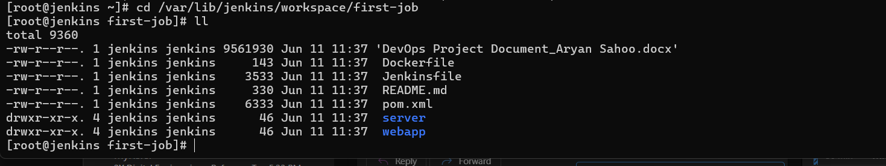
Artifacts built are successfully saved in the pipeline.

